Software Requirements Specification

for

Online Car Rental System

Version 1.0 approved

Prepared by Suraksha (15IT147)

Department of Information Technology, NITK Surathkal

9th January 2018

Table of Contents

Table of Contents ii

**Revision History…………………………………………………………………………………iii**

1. Introduction 1

1.1 Purpose 1

1.2 Document Conventions 1

1.3 Intended Audience and Reading Suggestions 1

1.4 Product Scope 1

1.5 References 1

2. Overall Description 2

2.1 Product Perspective 2

2.2 Product Functions 2

2.3 User Classes and Characteristics 2

2.3.1 Customer………………………………………………………………………………………………. 2

2.3.2 Admin…………………………………………………………………………………………………. 3

2.3.3 Employee……………………………………………………………………………………………… 3

2.3.4 Guest User……………………………………………………………………………………………...3

2.4 Operating Environment 3

2.5 Design and Implementation Constraints 3

2.6 User Documentation 4

2.7 Assumptions and Dependencies 4

3. External Interface Requirements 4

3.1 User Interfaces 4

3.2 Hardware Interfaces 4

3.3 Software Interfaces 4

3.4 Communications Interfaces 5

4. System Features 5

4.1 Log in 5

4.2 Cars 6

4.3 Bookings…………………………………………………………………………………………...6

4.1 Log in 5

4.1 Log in 5

4.1 Log in 5

4.1 Log in 5

4.1 Log in 5

5. Other Nonfunctional Requirements 6

5.1 Performance Requirements 6

5.2 Safety Requirements 7

5.3 Security Requirements 7

5.4 Software Quality Attributes 7

5.5 Business Rules 7

6. Other Requirements 7

Appendix A: Glossary 8

Appendix B: Analysis Models 8

1 Use casediagram.......……………….……………………..……………………………………10

2 Activity diagram………..…...……………….…………………………………………………11

2.1 Admin………………..………………………………………………………………11

2.2 Employee…..………………………………………………………………………...11

2.3 Customer…..…………………………………………………………………………12

2.4 Guest user…………..………………………………………………………………...12

3 Sequence diagram….…………………………………………….……………………………..13

3.1 Admin…………..……………………………………………………………………13

3.2 Guest user and customer……..………………………………………………………13

3.3 Employee……..……………………………………………………………………...14

4 Navigation diagram…..……………………………………………………………………….14

4.1 Admin.……….………………………………………………………………………14

4.2 Guest user and customer………..……………………………………………………15

5 ER diagram………………………….………………………………………………….………15

Revision History

|  |  |  |  |
| --- | --- | --- | --- |
| **Name** | **Date** | **Reason For Changes** | **Version** |
| Suraksha | 27/2/2018 | Analysis models finalized | 1.1 |
|  |  |  |  |

# Introduction

## Purpose

The purpose of this document is to present a detailed description about the online car rental system. It will explain the purpose and features of the system, the interfaces of the system, what the system will do, the constraints under which it must operate and how the system will react to external stimuli. This document is intended for both the stakeholders and the developers of the system.

## Document Conventions

This Document was created based on the IEEE template for System Requirement Specification Documents. The entire document uses Times New Roman font. The main headings are of size 18, sub-headings of size 14 and the remaining text of size 11.

## Intended Audience and Reading Suggestions

This SRS documentation is intended for developers and stakeholders.

This document gives an overall description of how an online car rental system will be designed. The platform on which it will be developed. It gives a superficial view of the tools that will be used in the process. Section 2 provides the detailed description of the system. Section 3 contains the requirements of the system. Section 4 contains system features.

## Product Scope

The Online Car Rental System(OCRS) is a website designed to rent cars. This website makes booking rented cars online easy and quick compared to the conventional method where the customer has to go to the car rental company office and get the same done. The website is accessible 24/7 to the customers and the employees. This saves a lot of time for the customer and is economically feasible for the company as well. Due its user-friendly interface the company will be successful in attracting more customers.

## References

IEEE Template for System Requirement Specification Documents:

<https://goo.gl/nsUFwy>

# Overall Description

## Product Perspective

The aim of this system is to shift from the conventional pen-paper car rental management to online car rental management system. The old methods include filling customer forms and maintaining customer records. This means that the company has to maintain a lot of paper work and physical records to keep track of its business. This also meant the customers, maybe tourists, businessmen etc., who were in need of rented cars had to go to the company office to go through the process of booking a car.

The online website is designed to provide access to various services offered by the company to the customers at the comfort of their homes. The customers will be able to search for cars based on brands and at the price range they prefer. They can book for cars and make online payment for the same. They will be able to send queries and feedback to the company using the contact information of the company.

The company will manage the services on the website. The company admin will be able to manage the bookings and the cars in the rental fleet. Admin can add or remove cars from the rental fleet. The employees will be able manage the feedback and query sent by customers and guest users. Employees will also be able to see the available cars. Employees will generate reports. Admin obtains report at the end of every business day. The employees can manage the bookings per day and add it the report. Guest users can view the cars available for rent and can contact the company for queries using information given on the site. Interested guest users can register to become a customer on the website.

## Product Functions

The system will be able to rent out vehicles. The system will be able to accept payments. The system will keep track of the rental fleet. There will be four actors in the system: Admin, Employees, Customer(User) and Guest user. The admin manages the car rental fleet. He can update, delete, add information about cars. The customer can create an account to start using the system services. Customer can search for cars, make bookings and make the payment. He can update information on his profile and give feedbacks or send queries. Employees can see the bookings per day and manage it. The guest users can browse car details and register with the system to rent cars. Guest users and customers can also contact the company by using contact information given on the website.

## User Classes and Characteristics

**2.3.1 Customer**

The customer will be able to do the following activity on the website:

1. Login
2. Search cars
3. Book car
4. Make payment
5. Update password
6. Update profile information
7. Post feedback
8. Send an enquiry
9. Check bookings
10. Cancel booking
11. Logout

**2.3.2 Admin**

The admin can perform the following actions:

1. Login
2. Manage vehicle brands(add/delete)
3. Manage the existing vehicles (update/add/delete details)
4. Check customer information
5. View the number of bookings
6. Manage Booking (Admin can confirm and Cancel Booking)
7. Manage queries and view feedback
8. Change password
9. Logout

**2.3.3 Employee**

The following are the functions that the employees can perform:

1. Login
2. Check bookings
3. Manage bookings
4. Generate report
5. Logout

**2.3.4 Guest user**

1. Browse car information
2. Register on the website
3. Contact using contact details

## Operating Environment

Processor: Intel® Xeon® processor 3500 series

HDD: Minimum 500GB Disk Space

RAM: Minimum 16GB

OS: Windows 8.1 and above

Database: SQL Server 2014 (SQL14)

Application: XAAMP, phpmyadmin

## Design and Implementation Constraints

* The system will be developed using PHP using XAMPP server.
* Ajax, JavaScript, HTML, jQuery will be used to design the user interface.
* SQL will be used for the backend design.
* Operating system: Windows OS
* Web browsers that the website will run on are: Mozilla Firefox, Google Chrome, Internet Explorer 8 and Opera.

## User Documentation

There will be no user manuals for this website as it will have a user-friendly interface and will be easy to use for anyone with basic online browsing skills.

## Assumptions and Dependencies

**2.7.1 Regularity Policies**

Each user has a unique login details and has not disclosed it to second person who can misuse this. The user is not supposed to share password with anyone.

**2.7.2 Hardware Limitations**

There is no limitation in the operating system in which Online Car Rental System will work. However,

the Car Rental System and the database will work on a server that needs to be always online. Users can access the system with Mozilla Firefox, Google Chrome, Internet Explorer 8 and Opera.

# External Interface Requirements

## User Interfaces

* All the users will see the same page when the website is opened. The home page appears with options to login, for customers and to register, for a new user.
* On clicking the login button, the user will be directed to the login section where email id and password has to be entered.
* After being authenticated by correct username and password, user will be redirect to their corresponding profile where they can do various activities.
* The About us page will contain the basic details about the services provided by the company.
* The FAQ page will address the basic queries that a new user is likely to have.
* The user interface will be simple and consistence, using terminology commonly understood by intended users of the system. The system will have simple interface, consistence with standard interface, to eliminate need for user training of infrequent users.

## Hardware Interfaces

* No extra hardware interfaces are needed.
* The system will use the standard hardware and data communication resources.
* The user will be able to use the website on his/her computer or laptop.

## Software Interfaces

**OS**: Windows 8.1 and above

**Web Browser**: The system is a web based application; it runs on modern web browser

such as Mozilla Firebox, Internet Explorer, Opera, and Chrome.

## Communications Interfaces

* This system will use communication resources which includes but not limited to, HTTPS protocol for communication with the web browser and web server and TCP/IP network protocol with HTTP protocol.
* This application will communicate with the database that holds all the booking information. Users can contact with server side through HTTP protocol by means of a function that is called HTTP Service. This function allows the application to use the data retrieved by server to fulfill the request fired by the user.

# System Features

These are statements of services the system should provide, how the system should react to

particular inputs, and how the system should behave in particular situations. It specifies the

application functionality that the developers must build into the product to enable users to

accomplish their tasks.

## Register new user

4.1.1 Description and Priority

A new user can register oneself on the website to start using the services provided by the car rental company. This feature is of high priority because users constitute important part of the car rental system.

4.1.2 Stimulus/Response Sequences

The user can click on the register button on the home page to start the registration process. The user has to enter relevant details and the system will verify that all the important fields are filled. On clicking the submit button the user data is added to the database.

4.1.3 Functional Requirements

REQ-1: A new user should be able to register oneself on the website. The user should be 18-year-old and above with a valid driving license.

REQ-2: All the details entered by the user is verified before being added to the database.

REQ-3: The new user’s data should be added to the database.

## Login

4.2.1 Description and Priority

This feature allows the admin, employees and registered users to login using their username and password. This feature is of high priority because it is important to prevent unauthenticated user from accessing another user’s account and modify the data.

4.2.2 Stimulus/Response Sequences

The user clicks on the login button. On the login page the user/admin/employee has to enter username and password. After verifying if username and password are correct the users are directed to their corresponding profiles. The user can click on logo out button to log out safely.

4.2.3 Functional Requirements

REQ-4: The system will allow the admin to login using email id and password.

REQ-5: The system will allow the customer with an account to login using email id and password.

REQ-6: The system will allow the employees to login using email id and password.

REQ-7: The system will allow the admin to log out.

REQ-8: The system will allow the customer to log out.

REQ-9: The system will allow the employee to log out.

## Update password

4.3.1 Description and Priority

Once they login, the admin, users and employees can change their account password. This feature is of high priority as the password change has to be recorded by the system and unauthorized user should not be able to access it.

4.3.2 Stimulus/Response Sequences

In their profile, on clicking on the change my password option the password can be changed. The password has to be entered twice for the system to record it properly.

4.3.3 Functional Requirements

REQ-10: The system should be able to record the password change.

REQ-11: The system should be able to prevent the user from logging in using old password.

## Update Profile

4.4.1 Description and Priority

The customer will be able to update one’s personal information on the website. This action has to be recognized by the system and the database has to updated accordingly. This feature has high priority.

4.4.2 Stimulus/Response Sequences

The user has to click on update profile option to perform this action. Click on the save button when done. The information will get updated in the database.

4.4.3 Functional Requirements

REQ-12: The system should be able to update the database according to new data entered by the customer.

## Search cars

4.5.1 Description and Priority

The guest users and customers should be able to search for cars based on brands and price range. This feature has high priority as it is the backbone of the OCRS. Without a variety of options available the customer won’t be able to find the perfect car to rent.

4.5.2 Stimulus/Response Sequences

The users can select the brands from the list. They can also adjust the price range.

4.5.3 Functional Requirements

REQ-13: The system should be able to show relevant search results.

REQ-14: The system should be able to show the detailed features and description of the car selected by the customer.

REQ-15: The system should be able to find cars that fall in the given range of price.

REQ-16: The system should be able to find cars of particular brand given the price range.

## Manage cars

4.6.1 Description and Priority

The admin should be able to add new cars into the rental fleet. Admin can remove old cars. The admin should be able to update the details of existing cars. This feature has high priority.

4.6.2 Stimulus/Response Sequences

The admin clicks on the manage rental fleet to perform these actions. On clicking on save button the database gets updated.

4.6.3 Functional Requirements

REQ-17: The system should be able to update its database according to the changes made by the admin.

REQ-18: The system should be able to display the availability of cars based on these details.

## Car Bookings

4.1.1 Description and Priority

This feature has high priority.

Customer: The customer should be able to make bookings for a particular car. And make payment for the car booked. The customer should also be able to cancel the booking. In this case the system should be able to refund the customer.

Admin: The admin can view the bookings made the customer. Admin can cancel the booking if need arises.

Employees: The employee can view the bookings made by different customers.

4.1.2 Stimulus/Response Sequences

When the customer finds a car that matches their requirement, they can proceed to book the car and make payment. These actions get updated in the system.

4.1.3 Functional Requirements

REQ-19: The system should be able to generate booking code to identify each booking uniquely.

REQ-20: The system should be able to generate transaction slip and number with the booking code.

REQ-21: The system should be able to carry out the transaction securely.

REQ-22: The admin should be able to cancel a booking.

REQ-23: In the event of a booking being cancelled the customer should be refunded. The system should be able to do this.

REQ-24: The system should be able to show all the previous bookings made by the customer. This also includes fund transactions.

REQ-25: The admin can check the user’s basic information.

## Feedback and Queries

4.1.1 Description and Priority

This feature allows the users to give feedback and send queries. The guest users can send queries using the contact details given on the website. This feature has medium priority.

4.1.2 Stimulus/Response Sequences

The customers can give feedback by using the give feedback option on their profile. The guest users can contact the company officials directly by using the contact details (phone number/email id) available on the website.

4.1.3 Functional Requirements

REQ-26: The admin should be able to read the feedbacks and reply to them.

REQ-27: The admin or employees should be able to reply to queries.

# Other Nonfunctional Requirements

## Performance Requirements

The system response time for every instruction conducted by the user must not exceed more

than a minimum of 10 seconds. The system should have high performance rate when

executing user’s input and should be able to provide response within a short time span usually

50 second for highly complicated task and 20 to 25 seconds for less complicated task.

## Safety Requirements

The system is updated regularly so that no customer data is lost. The customers can always contact the admin if any safety issue comes up. All the customers(users) have their own unique email id and password. The system will make sure that user data is protected. The online transaction of funds will happen over authenticated channel so that customer’s bank details are not leaked.

## Security Requirements

The system provides username and password to prevent the system from unauthorized

access. The password must be greater than eight characters. The subsystem should

provide a high level of security and integrity of the data held by the system, only authorized

personnel of the company can gain access to the company’s secured page on the system; and

only users with valid password and username can login to view user’s page.

## Software Quality Attributes

**5.4.1 User-friendly interface**

The online car rental system will be designed to be user friendly. The users should have the basic skill to browse and use a website. The website is very much self-explanatory, hence easy to use.

**5.4.2 Availability**

The system should always be available for access at 24 hours, 7 days a week. Also in the

occurrence of any major system malfunctioning, the system should be available in 1 to 2

working days, so that business process is not severely affected.

## Business Rules

* The system should always be available for access at 24 hours, 7 days a week. Also in the occurrence of any major system malfunctioning, the system should be available in 1 to 2 working days, so that business process is not severely affected.
* A customer will be able to access only his/her own profile.
* A user has to agree to the terms and conditions on the website before registering as a customer.
* The customer should be 18-year-old and above with a valid driver’s license.

# Other Requirements

There are no other requirements for the system at this stage.

Appendix A: Glossary

|  |  |
| --- | --- |
| **Abbreviation** | **Full Form** |
| OCRS | Online Car Rental System |
| Admin | The system administrator who manages the overall functions of the websites |
| Customer | A user who has already registered on the website |
| Employee | Person who works at the company |
| RAM | Random access memory |
| HDD | Hard Disk Drive |
| PHP | Hypertext Preprocessor |
| JavaScript | Programming language |
| Ajax | Asynchronous JavaScript and XML |
| jQuery | A JavaScript library |

Appendix B: Analysis Models

Use Case diagram:

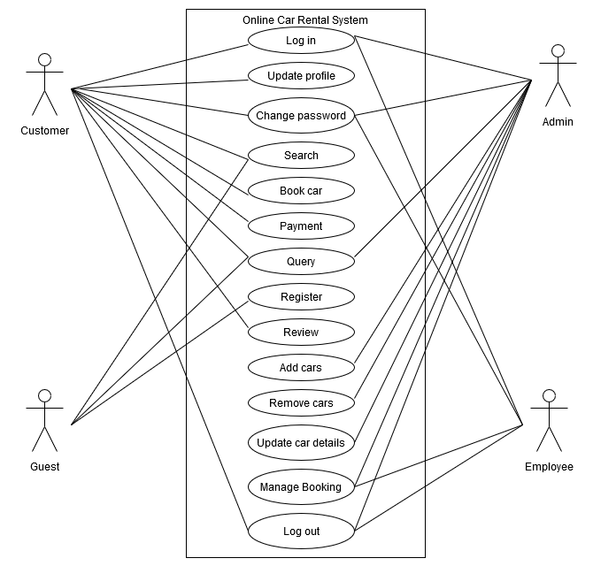

Activity diagram:

Admin:

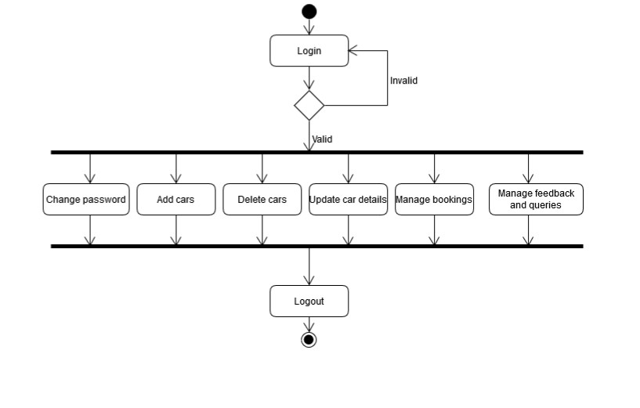

Employee:

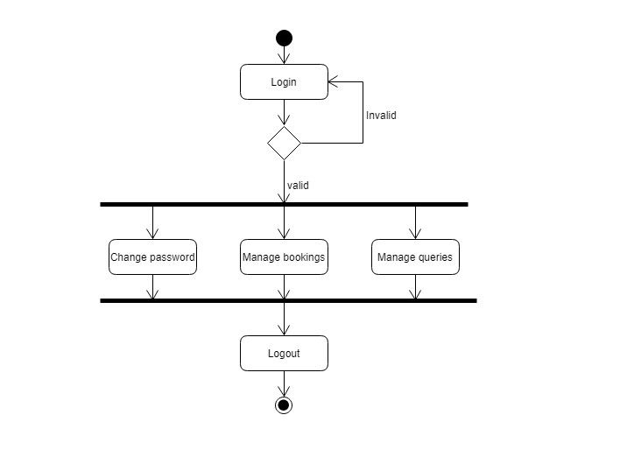

Customer:

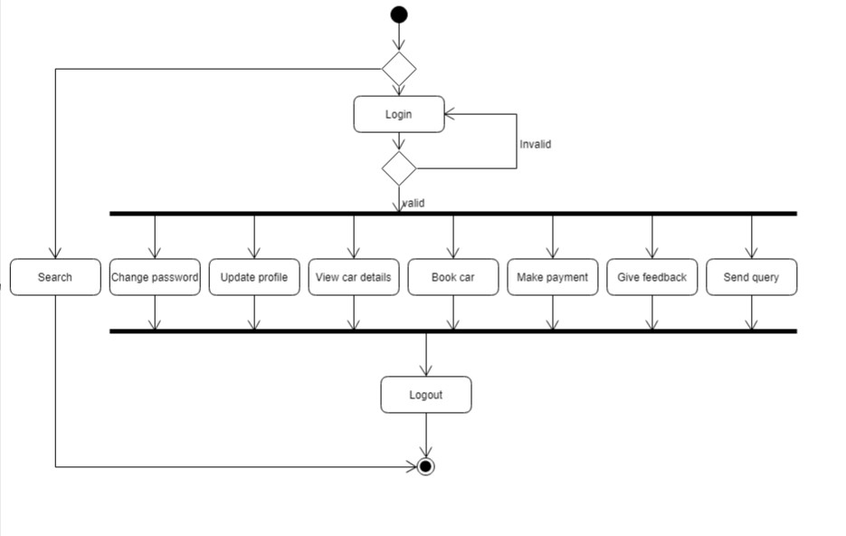

Guest user: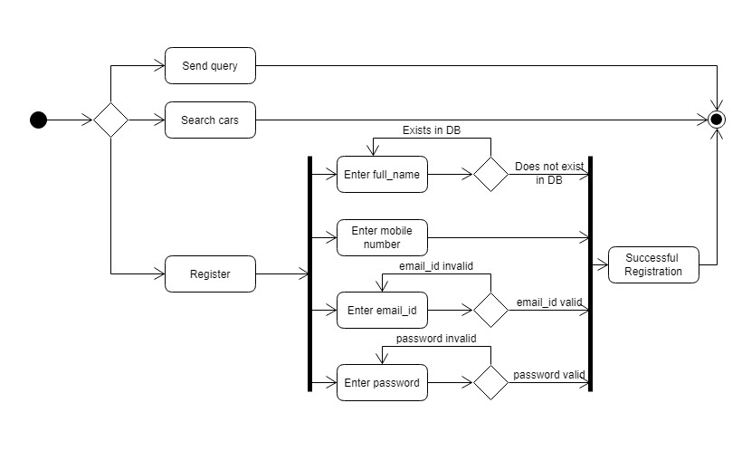

Sequence diagrams:

Admin:

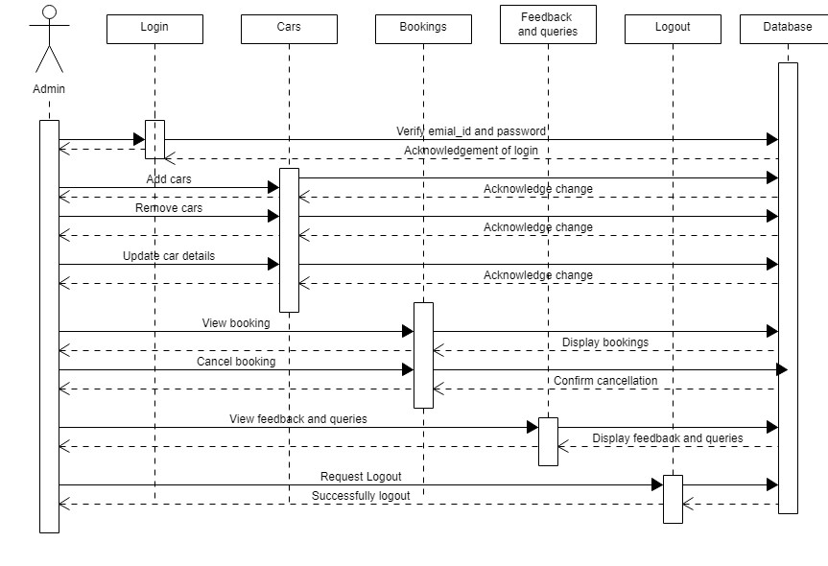

Guest user and customer:  
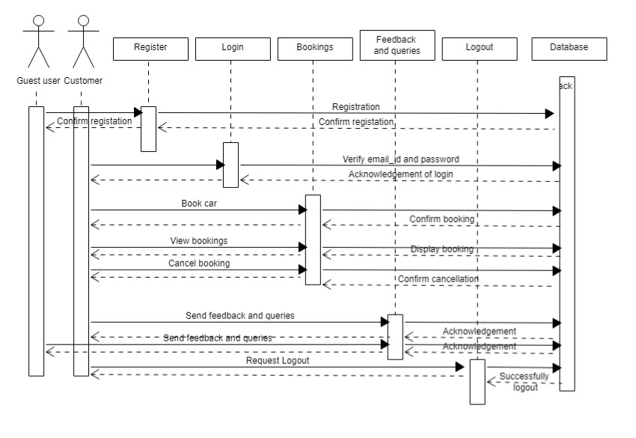

Employee:

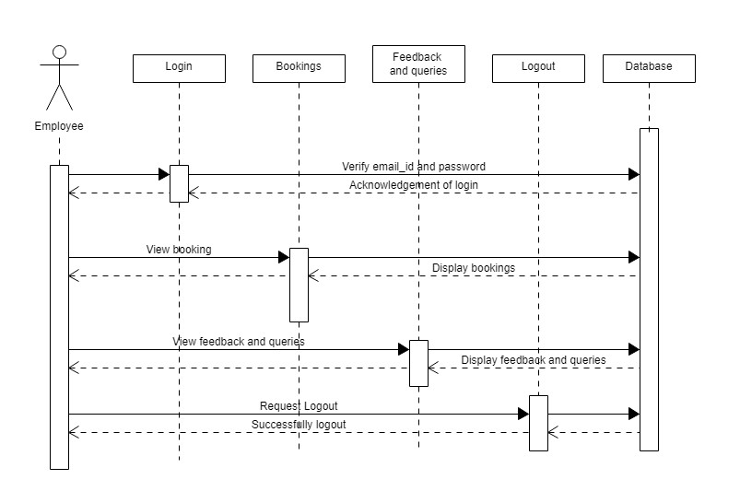

Navigation diagram:

Admin:

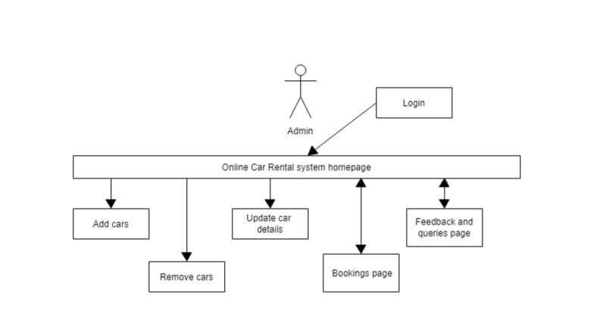

Guest user and customer:

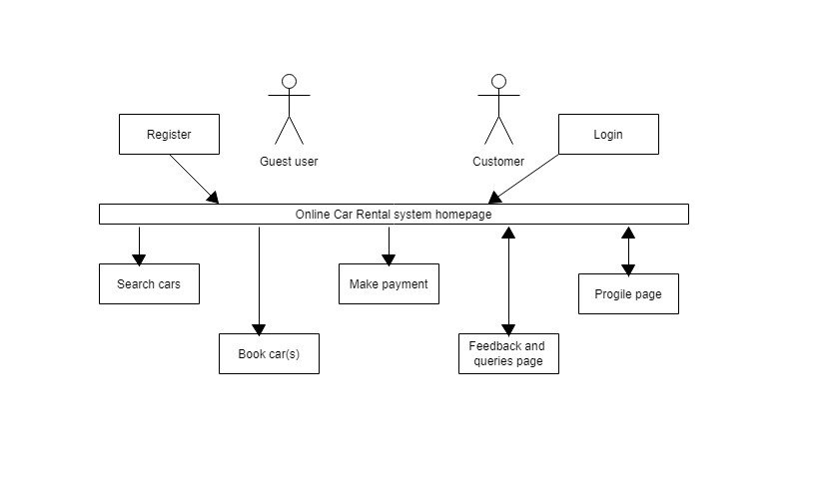

Entity-Relationship diagram:

